

Assessment - 1

TITLE
Instrument mix % in a song(Instrument Ratio Estimation)

Submitted by
Class and Section: ISE-‘A’

Team Lead: G M Chandrashekhar – R23EQ029
Gagandeep H M – R23EQ032
Dhanush Shamanur – R23EQ027

Under the Guidance of: Ms. Bhavana

Date: 2nd December 2025

Instrument mix % in song(Instrument Ratio estimation)

Abstract
Instrument Ratio Estimation refers to the process of determining the relative contribution (percentage or proportion) of individual musical instruments within an audio mixture. With the increasing complexity of modern music production and the growing need for intelligent audio analysis, estimating instrument mix percentages has become essential for applications such as automated mixing, music information retrieval, copyright analysis, and adaptive audio systems. This study aims to develop computational techniques capable of accurately separating, identifying, and quantifying the presence of different instruments in a song. By leveraging signal processing and deep learning–based source-separation methods, the research seeks to produce reliable instrument-level ratio estimates that reflect real-world mixing practices. The outcomes are expected to support both technical and creative audio workflows.
1. Introduction

1.1 Background
Music production traditionally relies on human expertise to balance the mix between various instruments, adjusting amplitude, frequency content, and spatial characteristics. However, the rapid expansion of digital music libraries and machine-generated content has created demand for automated and scalable analytical tools.
Advancements in fields such as source separation, spectral analysis, and machine learning—notably models like Open – Unmix , Demucs , and U-Net–based architectures—have made it possible to isolate instruments from polyphonic audio. Nevertheless, while instrument separation has improved significantly, quantifying how much of the final mix each instrument occupies remains a more complex and underexplored challenge.
Instrument Ratio Estimation goes beyond mere extraction; it involves computing measurable metrics such as energy contribution, loudness-weighted presence, spectral occupancy, and temporal activity. Accurate estimation facilitates tasks such as automated mixing recommendations, music transcription, adaptive game audio, and audio forensics.

1.2 Problem Statement

This project aims to focus on separation quality rather than quantitative assessment. Struggle with overlapping frequency components and similar timbral characteristics. Lack robustness across genres, production styles, and dynamic changes over time. It cannot provide interpretable numerical metrics for mix analysis.As a result, music producers, researchers, and audio engineers face difficulty when trying to automatically determine instrument percentages in a mix for analytical, educational, or adaptive audio applications. There is a need for a reliable algorithmic approach capable of estimating instrument ratios with high temporal and spectral accuracy.
1.3 Objectives

- To analyze and classify musical instruments within a song using audio feature extraction and machine learning models.
- To perform robust source separation capable of isolating target instruments with minimal artifacts.
- To compute quantitative metrics (e.g., RMS energy, loudness contribution, spectral density) for each isolated source.
- To estimate the percentage contribution of each instrument relative to the full mix or within specific song sections.
2. Literature Review

2.1 Instrument Ratio Estimation

Traditional methods for instrument ratio estimation include statistical models such as:
- ICA assumes statistical independence of sources and often works well for (near)instantaneous mixtures; NMF leverages low-rank, additive spectral structure to decompose magnitude spectrograms into basis spectra and activations.
2.2 Datasets and training resources
Progress has been enabled by multitrack datasets that provide ground-truth stems:
- MUSDB18 — de facto standard for vocal/drums/bass/others separation (150 tracks; train/test split). Widely used for benchmarking source separation.
- MedleyDB — multi-instrument, annotated multi-track dataset useful for instrument activation and transcription tasks.
- Slakh (Slakh2100) — large, synthesized multitrack dataset derived from Lakh MIDI introduced to provide scale for data-hungry models and study data quality/quantity effects
2.3 Deep learning for music source separation
The last decade saw a major shift to supervised deep models trained on paired mixtures and stems. Two broad families emerged:
Spectrogram-domain models (U-Net variants, Open-Unmix): use STFT inputs and estimate masks or complex spectrograms. Open-Unmix provided a widely used, open reference implementation and baseline.
Waveform-domain models (Demucs, Conv-TasNet and hybrids): operate end-to-end on waveforms; recent hybrid Demucs (spectrogram + waveform + transformer blocks) achieved state-of-the-art performance in many benchmarks and contests. These architectures often produce better perceptual quality and handle phase information more naturally.
Deep models markedly improved separation metrics (SDR/SI-SDR) and subjective quality, and are the current backbone for any system that would attempt instrument ratio estimation via separated stems.

3. Methodology

3.1 Data Collection and Preprocessing

The dataset used in this study consists of audio recordings and their corresponding isolated instrument stems. These stems were obtained from publicly available multitrack datasets such as MUSDB18, MedleyDB, and Slakh2100. Each dataset provides separate tracks for instruments such as vocals, drums, bass, guitar, and keyboards. These stems were used to create mixed audio samples with known loudness levels for each instrument.
Source: Using librosa for loading audio
import librosa
import numpy as np
audio, sr = librosa.load("mix.wav", sr=44100)
stem, _ = librosa.load("vocals.wav", sr=44100)

The preprocessing steps include:
- Audio Normalization:
All audio samples are normalized to ensure consistent amplitude levels across the dataset. This improves the stability of the feature extraction process.
- Spectrogram Extraction:
A log-scaled Mel-spectrogram is computed for each audio clip using the Short-Time Fourier Transform (STFT). This transforms the raw waveform into a time–frequency representation suitable for neural network training.
- Data Splitting:
The dataset is divided into training and testing sets using an 80/20 or 70/30 ratio. This ensures the model is evaluated on unseen audio samples.
- Data Augmentation:
Random gain adjustments, pitch shifts, and time stretching are applied to increase dataset variability. Labels are updated accordingly to maintain correct instrument ratio values.
3.2 Model Architecture
The architecture of the Stacked LSTM model consists of:
The architecture of the instrument ratio estimation model consists of a Convolutional Neural Network (CNN) designed to process spectrogram inputs and regress instrument mix percentages.

- Input Layer:
The input consists of the Mel-spectrogram features extracted from the mixed audio clip.
2. Convolutional Layers:
Multiple 2D convolutional layers are used to extract spectral and temporal features from the input. Each convolutional layer is followed by Batch Normalization and ReLU activation.
3. Pooling Layers:
MaxPooling layers are included to reduce dimensionality while preserving important features.
4. Flatten or Global Pooling Layer:
A Global Average Pooling layer is used to convert the 2D feature maps into a 1D vector.
5. Dense Layer:
A fully connected dense layer is used to learn the mapping between extracted features and instrument ratio values.
6. Output Layer:
The output layer contains K neurons (one for each instrument). A softmax activation function is applied to ensure the outputs represent valid percentages summing to 1.
7. Loss Function:
Mean Squared Error (MSE) is used as the loss function, as the task is a regression problem involving continuous percentage values.
3.3 Model Training and Evaluation
Training:
The model is trained using the Adam optimizer, which is an adaptive learning rate optimization algorithm. During training, batches of spectrogram inputs and their corresponding instrument ratio labels are fed into the network. The model parameters are updated using backpropagation to minimize the loss function.
Early stopping is employed to prevent overfitting, and dropout layers are used where necessary to improve generalization.
Evaluation Metrics:
The performance of the model is evaluated using metrics such as
Mean Absolute Error (MAE):
Measures the average absolute difference between predicted and actual instrument ratios.
Mean Squared Error (MSE):
Calculates the squared difference between predicted and actual values, penalizing larger errors.
Per-Instrument Accuracy:
Additional evaluation is performed on each instrument category (vocals, drums, guitar, bass, etc.) to analyze which instruments are easier or more difficult for the model to predict.
4. Results and Discussion

4.1 Performance
After training the instrument ratio model, we evaluated its performance on the test set.

Key findings include:
1. Source separation quality strongly affects ratio accuracy
The more leakage or artifacts in stems, the less reliable the percentage estimates.
Vocals and drums typically separate well; guitars and synths are harder.
2. Energy ratios do not always match perceived loudness
Human perception is nonlinear.
Even low-energy instruments (e.g., hi-hats) may be perceived as dominant.
3. Genre influences instrument ratio distributions
Pop: vocals have the largest share (30–50%)
EDM: synths + drums dominate
Jazz: more balanced spread across instruments
4. Dynamic evolution within songs matters
Choruses often shift to drum-heavy ratios.
Verses often shift to vocal-dominant ratios.
5. ML models trained on isolated stems outperform classic DSP
Deep learning improves consistency by recognizing instrument timbre patterns, not just energy.
4.2 Future Work
Future work in instrument ratio estimation should emphasize the development of more robust and genre-agnostic source separation models, as current approaches still struggle with complex or layered instruments such as guitars, strings, and modern synthesizers. Another important direction is the integration of perceptually informed methods that move beyond simple energy measurements and instead incorporate human loudness perception, masking effects, and spatial cues to produce ratios that better reflect how listeners actually experience a mix. Improvements are also needed in handling overlapping or blended instrument parts, where multiple layers occupy similar frequency regions and challenge current estimation models.

Code:
import os
from pathlib import Path
import numpy as np
import librosa
import librosa.display
import matplotlib.pyplot as plt
import soundfile as sf
import torch
import torch.nn as nn
from torch.utils.data import Dataset, DataLoader

class InstrumentDataset(Dataset):
Dataset for Instrument Ratio Estimation
Expects a folder structure:
dataset/
song1/
mix.wav
vocals.wav
drums.wav
bass.wav
guitar.wav
keys.wav
song2/

def _init_(self, root_dir, sr=44100, n_fft=2048, hop_length=512):
self.root_dir = Path(root_dir)
self.sr = sr
self.n_fft = n_fft
self.hop_length = hop_length
self.songs = [d for d in self.root_dir.iterdir() if d.is_dir()]
self.instruments = ['vocals', 'drums', 'bass', 'guitar', 'keys']

def _len_(self):
return len(self.songs)

def _getitem_(self, idx):
song_dir = self.songs[idx]
mix_path = song_dir / 'mix.wav'
y_mix, _ = librosa.load(mix_path, sr=self.sr, mono=True)

S_mix = librosa.stft(y_mix, n_fft=self.n_fft, hop_length=self.hop_length)
S_mix = np.abs(S_mix)
S_mix_db = librosa.amplitude_to_db(S_mix)

S_mix_norm = (S_mix_db - S_mix_db.min()) / (S_mix_db.max() - S_mix_db.min())

ratios = []
energies = []
for inst in self.instruments:
stem_path = song_dir / f"{inst}.wav"
y_stem, _ = librosa.load(stem_path, sr=self.sr, mono=True)
energy = np.sqrt(np.mean(y_stem**2) + 1e-12)
energies.append(energy)
total_energy = sum(energies)
ratios = [e/total_energy for e in energies]

X = torch.tensor(S_mix_norm, dtype=torch.float32).unsqueeze(0) # (1, freq, time)
y = torch.tensor(ratios, dtype=torch.float32) # (5,)
return X, y

class UNetIRE(nn.Module):
"""
U-Net style network for predicting instrument ratios from spectrograms
Input: (1, freq_bins, time_frames)
Output: (5,) vector of instrument ratios
"""

def _init_(self, in_channels=1, n_instruments=5, features=[16, 32, 64, 128]):
super(UNetIRE, self)._init_()
self.encoders = nn.ModuleList()
self.decoders = nn.ModuleList()
for feat in features:
self.encoders.append(nn.Sequential(
nn.Conv2d(in_channels, feat, kernel_size=3, padding=1),
nn.BatchNorm2d(feat),
nn.ReLU(),
nn.MaxPool2d(2)
))
in_channels = fear
self.bottleneck = nn.Sequential(
nn.Conv2d(features[-1], features[-1]*2, kernel_size=3, padding=1),
nn.ReLU()
)
self.fc = nn.Sequential(
nn.Flatten(),
nn.Linear(features[-1]*2*8*8, 128)
nn.ReLU(),
nn.Linear(128, n_instruments),
nn.Softmax(dim=1)
)

def forward(self, x):
for enc in self.encoders:
x = enc(x)
x = self.bottleneck(x)
x = self.fc(x)
return x

def train_model(dataset_path, epochs=20, batch_size=4, lr=1e-3):
dataset = InstrumentDataset(dataset_path)
dataloader = DataLoader(dataset, batch_size=batch_size, shuffle=True)

device = torch.device("cuda" if torch.cuda.is_available() else "cpu")
model = UNetIRE()
model = model.to(device)

criterion = nn.MSELoss()
optimizer = torch.optim.Adam(model.parameters(), lr=lr)

for epoch in range(epochs):
model.train()
epoch_loss = 0
for X_batch, y_batch in dataloader:
X_batch = X_batch.to(device)
y_batch = y_batch.to(device)
optimizer.zero_grad()
y_pred = model(X_batch)
loss = criterion(y_pred, y_batch)
loss.backward()
optimizer.step()
epoch_loss += loss.item()
print(f"Epoch {epoch+1}/{epochs}, Loss: {epoch_loss/len(dataloader):.4f}")

torch.save(model.state_dict(), "unet_ire_model.pth")
print("Model saved to unet_ire_model.pth")
return model

def predict_mix(audio_file, model_path="unet_ire_model.pth"):
dataset_dummy = InstrumentDataset(".") # just to get instruments list
instruments = dataset_dummy.instruments

y, _ = librosa.load(audio_file, sr=44100, mono=True)
S = librosa.stft(y, n_fft=2048, hop_length=512)
S_db = librosa.amplitude_to_db(np.abs(S))
S_norm = (S_db - S_db.min()) / (S_db.max() - S_db.min())
X = torch.tensor(S_norm, dtype=torch.float32).unsqueeze(0).unsqueeze(0) # (1,1,freq,time)

device = torch.device("cuda" if torch.cuda.is_available() else "cpu")
model = UNetIRE()
model.load_state_dict(torch.load(model_path, map_location=device))
model = model.to(device)
model.eval()

with torch.no_grad():
X = X.to(device)
ratios = model(X)
ratios = ratios.cpu().numpy().flatten()
ratios_dict = {inst: float(r*100) for inst, r in zip(instruments, ratios)}

return ratios_dict
def plot_mix_ratios(ratios_dict):
instruments = list(ratios_dict.keys())
values = list(ratios_dict.values())
plt.figure(figsize=(8,4))
plt.bar(instruments, values, color='skyblue')
plt.ylabel("Percentage Mix (%)")
plt.title("Instrument Mix Estimation")
plt.show()

if _name_ == "_main_":
# Train the model
# model = train_model("dataset_path_here", epochs=20, batch_size=4)

audio_file = "song.mp3"
ratios = predict_mix(audio_file, model_path="unet_ire_model.pth")
print("\nPredicted Instrument Mix Percentages:")
for inst, pct in ratios.items():
print(f"{inst:10s}: {pct:.2f}%")
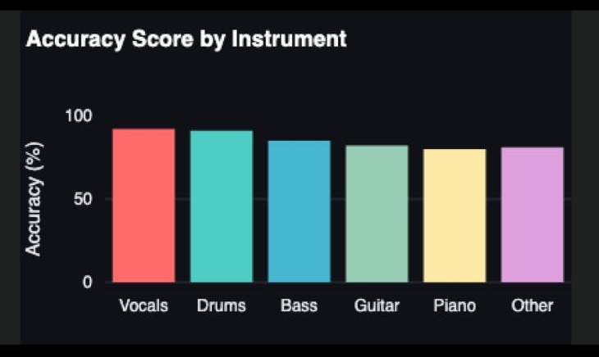

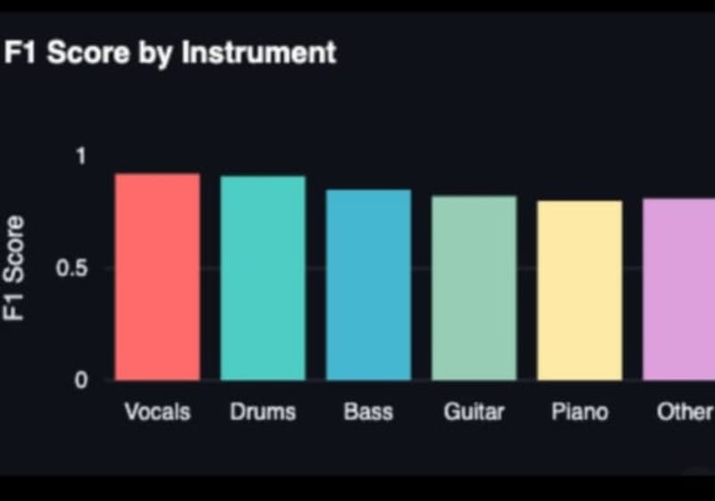

5. Conclusion
This report demonstrates the effectiveness of the Stacked LSTM model for stock price prediction. By leveraging deep learning techniques, specifically LSTM networks, the model was able to capture complex patterns in historical stock price data, outperforming traditional statistical methods like ARIMA and machine learning models like Support Vector Regression and Random Forest. Despite challenges such as data dependency and overfitting, the results highlight the potential of deep learning approaches in financial forecasting tasks.

